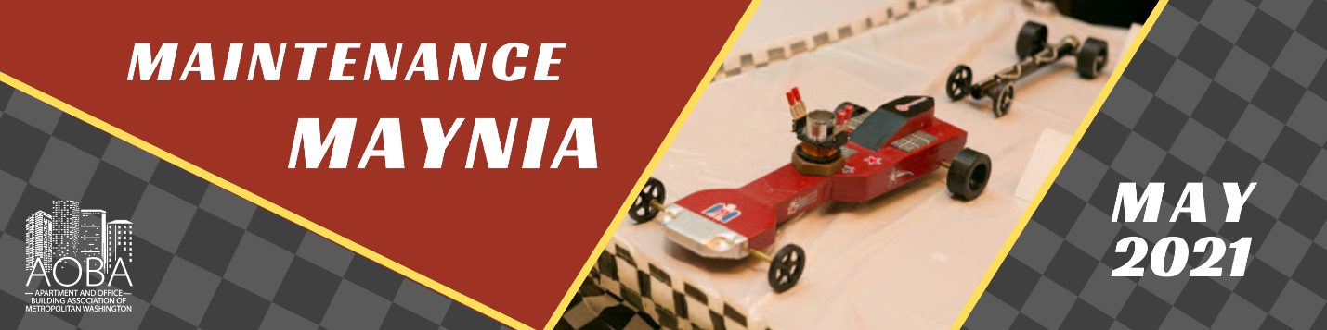

2021 Maintenance Maynia Award Application and Nomination Form
Submit by April 1st to Brandy Peak @ bpeak@aoba-metro.org
Please answer the questions in a different color font.

Demographic Details
1. Tell us who you are
First Name:
Last Name:
Management Company (or Company):
Property, If applicable:
Email:
Cell Phone:

2. Are you applying for an award
Yes
No

Demographic Details, P2
3. If you are not applying for an award, who are you nominating? (It is okay if you do not know a lot of these details!)
First Name
Last Name
Email
Cell Phone
Management Company
Property

4. Please tell us the award you are applying for or nominating someone for.
Maintenance Technician of the Year
Maintenance Supervisor of the Year
Regional Maintenance Supervisor of the Year
MacGyver of the Year
Rookie of the Year
MVP of the Year
Best Service Team of the Year

Maintenance Technician of the Year
5. Give examples of how you contribute to the success of the property and your company.
6. What technical skill could you improve in the most, and how are you working to improve that skill?
7. How do your efforts impact overall resident satisfaction and provide for a great customer experience for residents?
8. What was the most difficult obstacle you were faced with in servicing resident needs during the COVID-19 pandemic and what did you do to overcome it?
9. What efforts and resources do you plan to use to advance your career?
10. Although letters of recommendation aren't required, they are encouraged. Please upload your letter of recommendation.

Maintenance Supervisor of the Year
5. Give examples of how you contribute to the success of the property and your company.
6. Describe efforts you take to keep your site team motivated and performing at a high level.
7. What was the most difficult obstacle you were faced with in servicing resident needs during the COVID-19 pandemic and what did you do to overcome it?
8. What do you do to set an example for your team to achieve desired results?
9. Give specific examples of resources you use to improve your industry knowledge and professional development, and how they have impacted your career.
10. Although letters of recommendation aren't required, they are encouraged. Please upload your letter of recommendation.

Regional Maintenance Supervisor of the Year
5. Give examples of how you contribute to the success of your company and your site teams.
6. Describe efforts you take to keep your site teams motivated and performing at a high level.
7. What was the most difficult obstacle you were faced with in managing your team during the COVID-19 pandemic and what did you do to overcome it?
8. How do you balance achieving corporate initiatives and developing on-site motivation and performance?
9. Give specific examples of resources you use to improve your industry knowledge and professional development, and how they have impacted your career.
10. Although letters of recommendation aren't required, they are encouraged. Please upload your letter of recommendation.

MacGyver of the Year Award
5. Give examples of how you contribute to the success of the property and your company.
6. Where others saw challenges, you saw opportunities. Tell us a story about how you fixed something that others thought was impossible using unique tools or parts?
7. Describe a policy or procedure that you created after recognizing a problem or deficiency?
8. Can you think of a time when you prevented a small issue/problem from turning into something that potentially could have become much larger or costlier to your property, if you hadn’t intervened?
9. Tell us how you stay up to date on training or acquiring new skills to use in your craft? How to you go above and beyond the training that your company provides?
10. Although letters of recommendation aren't required, they are encouraged. Please upload your letter of recommendation.

Rookie of the Year
5. Give examples of how you contribute to the success of the property and your company.
6. How do your efforts impact overall resident satisfaction and provide for a great customer experience for residents?
7. What was the most difficult obstacle you were faced with during the COVID-19 pandemic and what did you do to overcome it?
8. If you could implement one change at your apartment community, what would it be and why?
9. What is your favorite part of your job and why?
10. Although letters of recommendation aren't required, they are encouraged. Please upload your letter of recommendation.

MVP of the Year
5. Give examples of how you contribute to the success of the property and your company.
6. Please provide an example of how you went above and beyond your job duties.
7. How do you manage your time with the additional responsibilities you assume?
8. If your team had to describe you in five words, what would they say?
9. Although letters of recommendation aren't required, they are encouraged. Please upload your letter of recommendation.

Best Service Team of the Year
5. Tell us why your service team is the best.
6. In the past year, what would you describe as your biggest success as a team?
7. Describe the ways this team pulls together and backs each other up in times of heavy workload or when understaffed.
8. What are some of the elements of this group's teamwork that contribute to the overall financial stability of the property?
9. Give me an example of a time when your team worked especially well together on a large project. Describe the process and the outcome.
10. Although letters of recommendation aren't required, they are encouraged. Please upload your letter of recommendation.

